Christian Angel, Emily Flauto, Finn Baldwin, Kyira Fields

Untitled Team

Untitled Space Game / Ilistrion

One Sentence Overview - A horizontal scrolling shoot ‘em up with a focus on traveling through space, avoiding planets and debris, fighting unique enemies, and gaining unique power-ups to take on the final boss.

Platform - PC

Genre - Shoot 'em up, Scrolling shooter

Target Audience - Players who enjoy retro shoot ‘em ups

Game Summary - The game is a horizontally scrolling shoot ‘em up with a focus on obstacle avoidance and shooting. The game consists of one large stage with a boss ship at the end. The stage will include planets and debris to dodge, enemies that shoot at you in various patterns to fight, and power-ups. These power-ups give the player better weapons, extra movement options, and/or better defenses. The player will have three hits before dying, allowing them to learn from mistakes and get better as the game progresses. Getting through the stage and defeating the final boss will end the game and show the credits.

Game Outline - The game takes place in a generic space setting. The player has basic movement abilities at the start, allowing them to move up, down, left, and right, as well as the ability to shoot. The level is split into unmarked sections, each with their own variety of enemies. The boss is its own section with advanced bullet patterns and movement, and beating the boss will end the game. This is meant to test the player’s abilities and power-up status. The game is fully singleplayer with no additional functionality beyond playing the game itself.

Unique Selling Points:

* One large stage
* Upgradeable player stats
* Retro space esque game

Similar Competitive Products:

* Gradius
* Drainus
* R-Type
* Super Hydora
* Touhou

Player

* Controls the spaceship from an outside perspective.
* Starts with standard movement speed and a single laser weapon.
* Has 3 hearts, if the player has no more hearts remaining, they lose.
* Can collect power ups such as weapon upgrades, movement alterations, and higher defense.
* All the power ups carry over to the boss battle.
* Green or blue rounded ships, change color when certain number of powerups are enabled?

Stage Structure

* One large level
* It has obstacles that cannot be destroyed, enemies, and powerups.
* The end of the stage contains the final boss.

Boss Fight

* The boss is a lot larger than normal enemies.
* Shoots more bullets.
* Has higher health and defense.
* Without powerups, it is very difficult.

Enemies

* Drones
  + Moves around in a random pattern
  + One doesn’t shoot, one shoots infrequently, one more frequent shooting
  + Small grey ships
* Basic Enemies
  + Tracks the player’s movements
  + Bigger and harder to dodge
  + Each one behaves differently
  + Medium sized futuristic ships

Obstacles

* Rocks
  + Half heart of damage
* Planets
  + Half heart of damage
* Explosive Rocks
  + Full heart of damage
* Other Ships
  + Drone and drone bullets take half a heart
  + Basic enemies and basic enemy bullets take a full heart

Scope Creep Ideas

* Multiple players characters with different stats for each that can be switched between
* More advanced bullet patterns/bullet hell
* Multiple weapon types that the player can use
* Losing power-ups when you get hit
* High score tracking
* Different kinds of projectiles

Relevant Links

* [Universal LPC Sprite Sheet Character Generator](https://liberatedpixelcup.github.io/Universal-LPC-Spritesheet-Character-Generator/#?body=Body_color_blue&head=Minotaur_blue&legs=Pants_black&sex=muscular&ears_inner=none_Side_Wolf_Ears_Skintone&weapon=Glowsword_red)
* [Liberated Pixel Cup styleguide](https://lpc.opengameart.org/static/LPC-Style-Guide/build/styleguide.html#props-and-other-objects)
* [New Piskel](https://www.piskelapp.com/p/create/sprite/)
* [Platformer Characters · Kenney](https://kenney.nl/assets/platformer-characters)
* [Tiled](https://www.mapeditor.org/)
* [Bfxr](https://www.bfxr.net/)

[Project Assets](https://drive.google.com/drive/folders/1Bh7WI66efwaunRTA2gKFH69-uu2kfNXb?usp=sharing) - Download link to all assets (Including sound files not shown here)

**↓ Images Below (Actual Files are also in our discord chat) ↓**

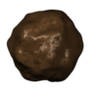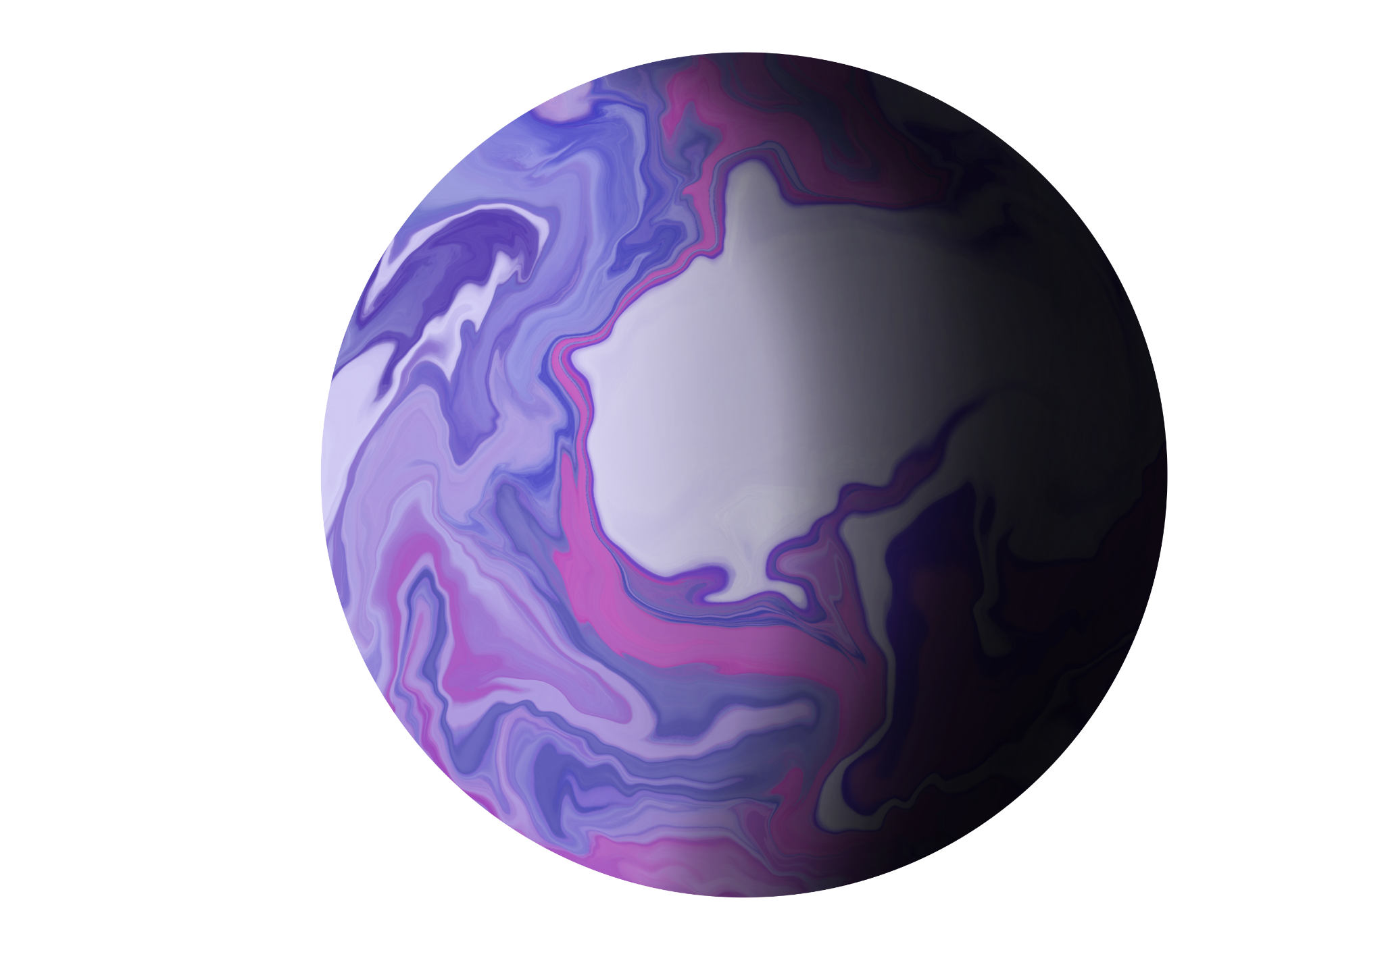

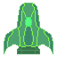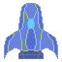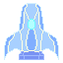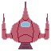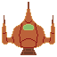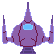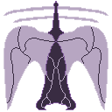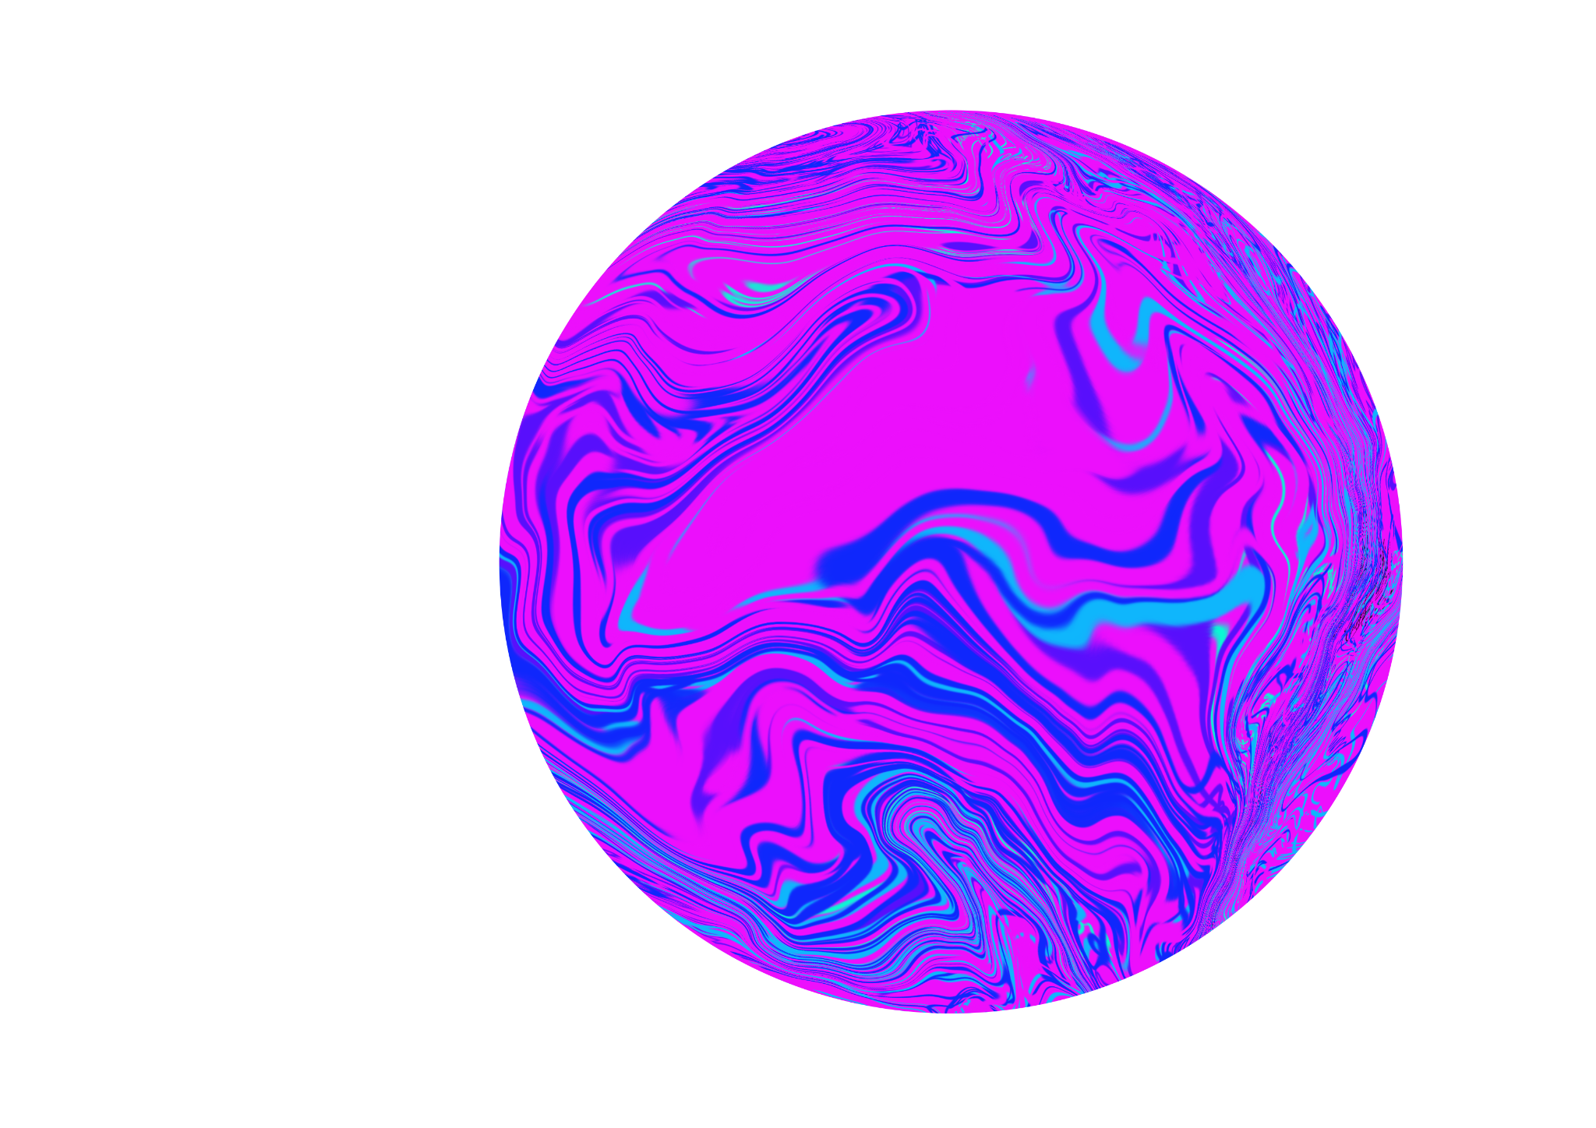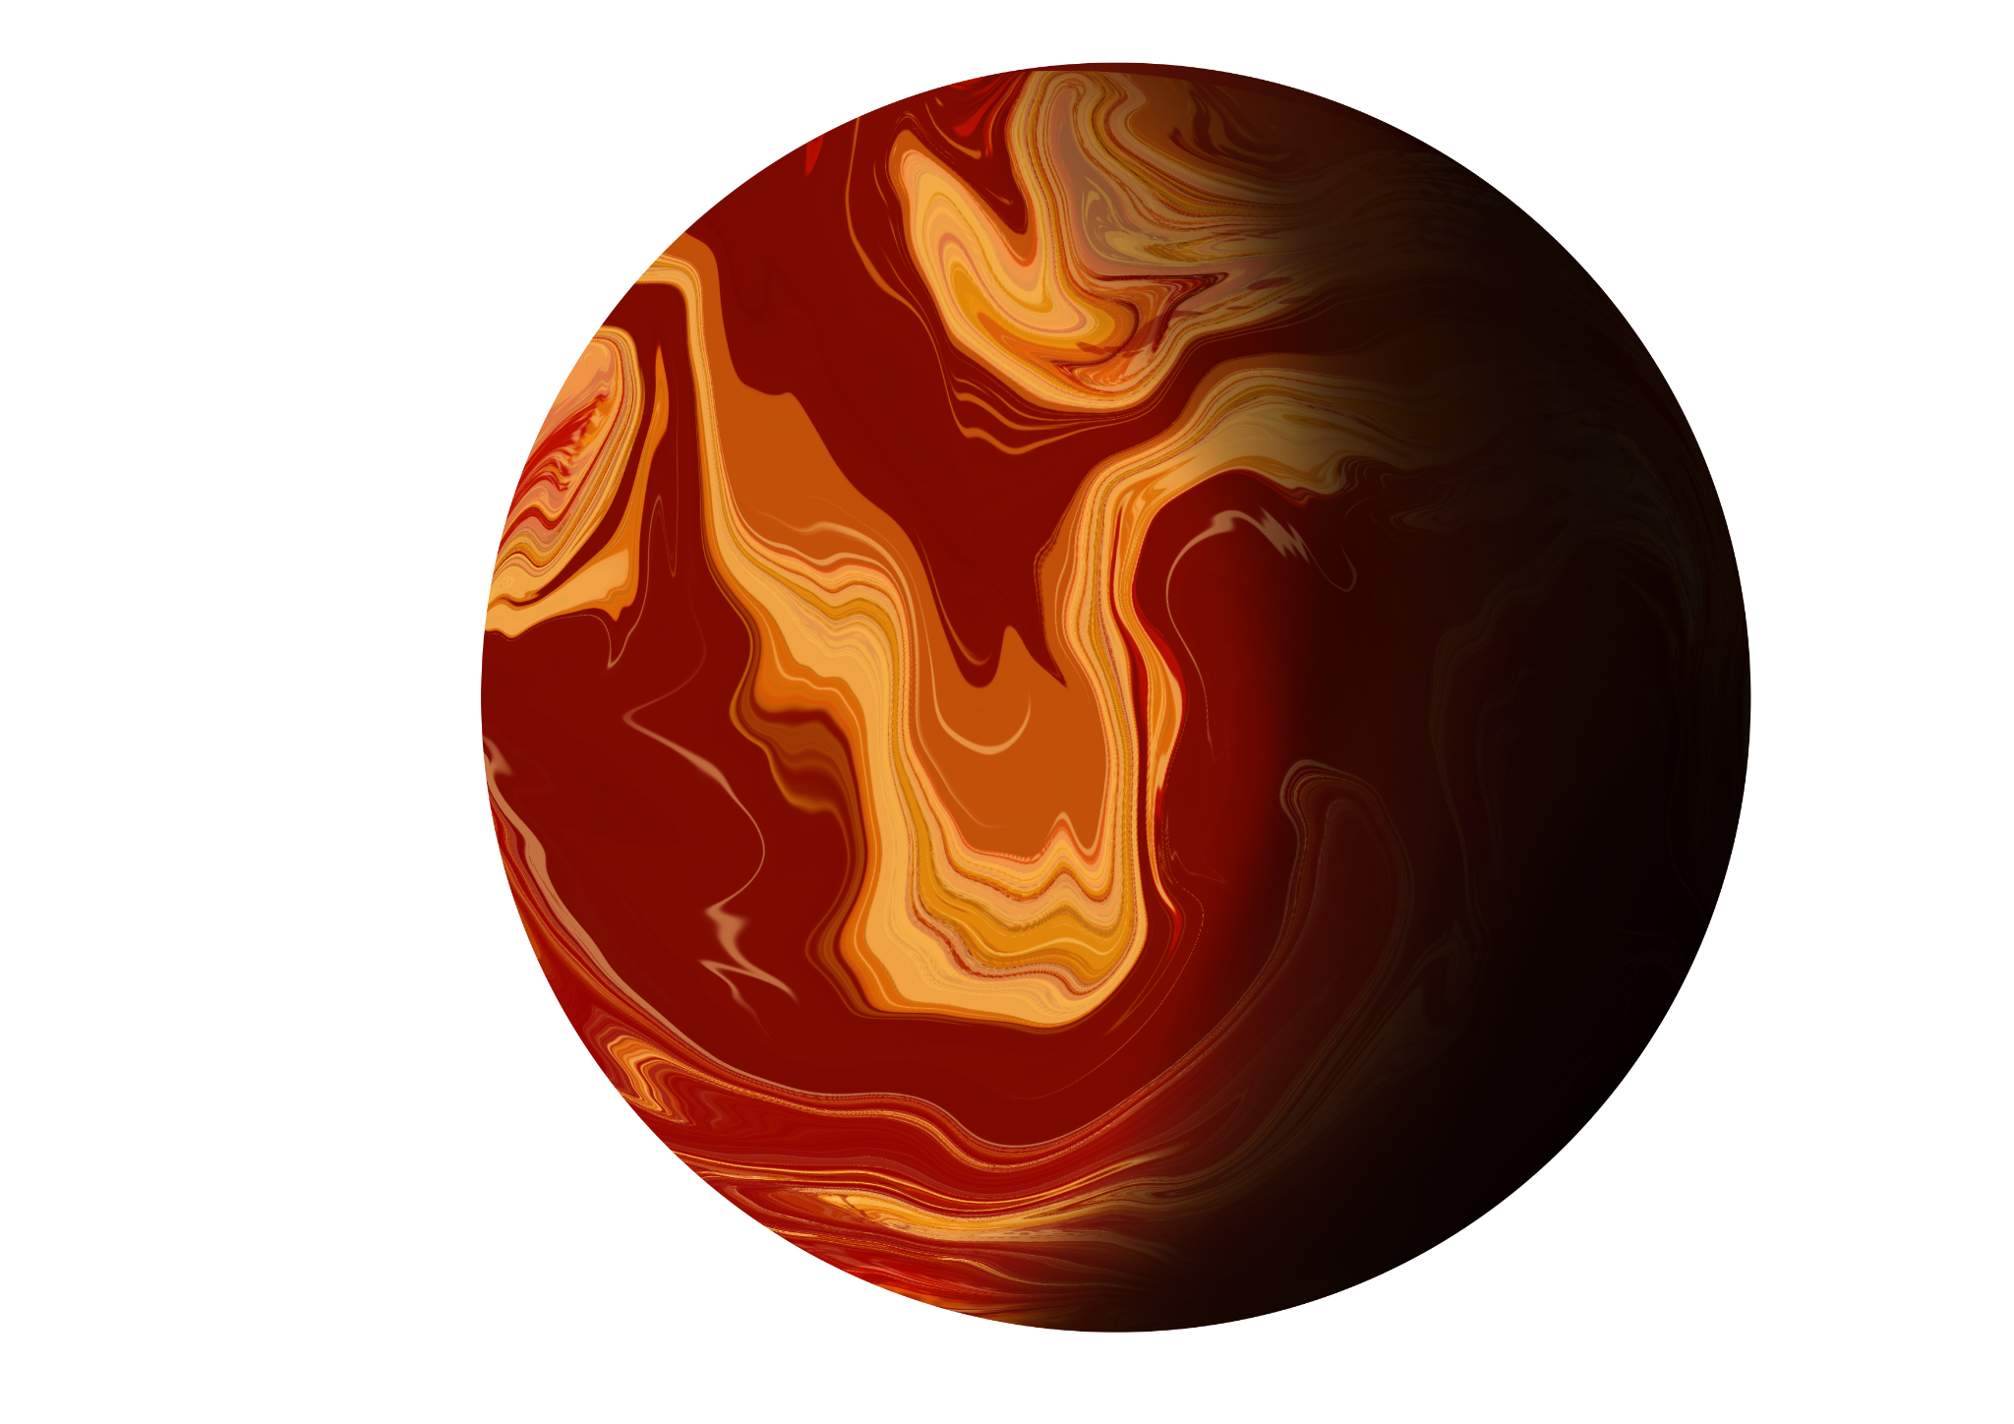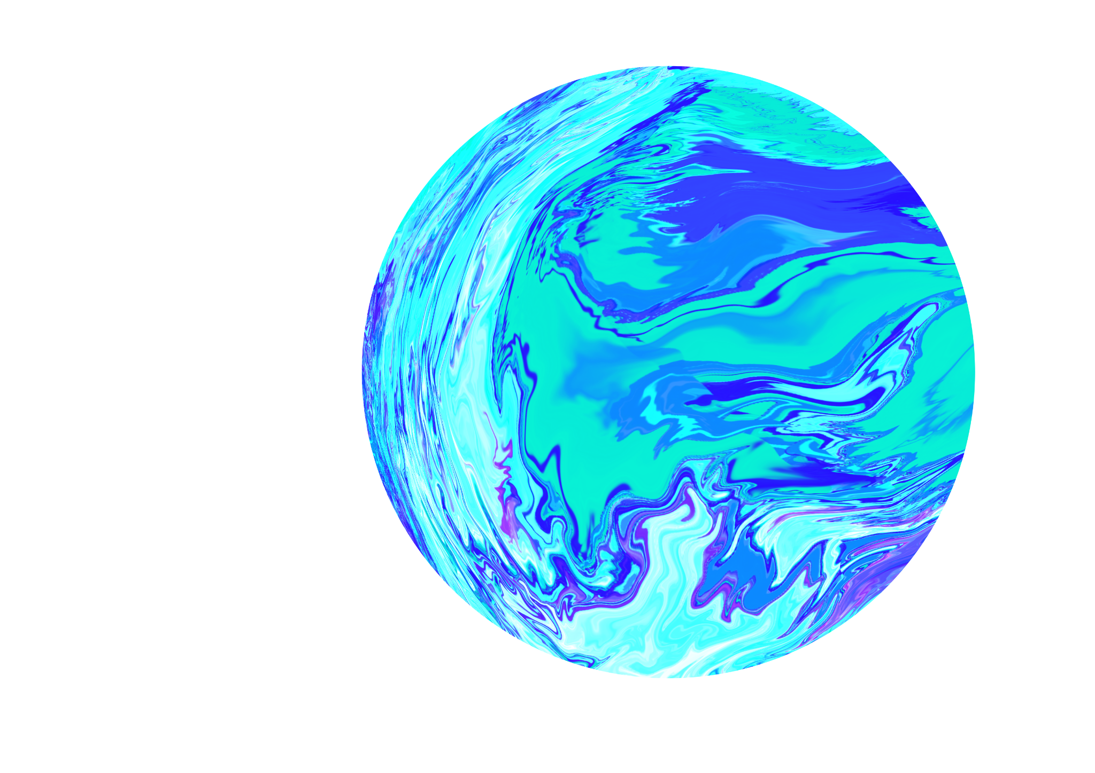



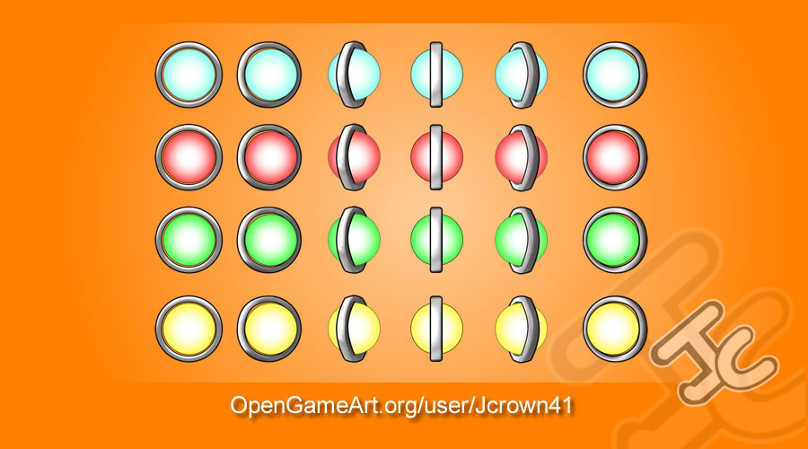

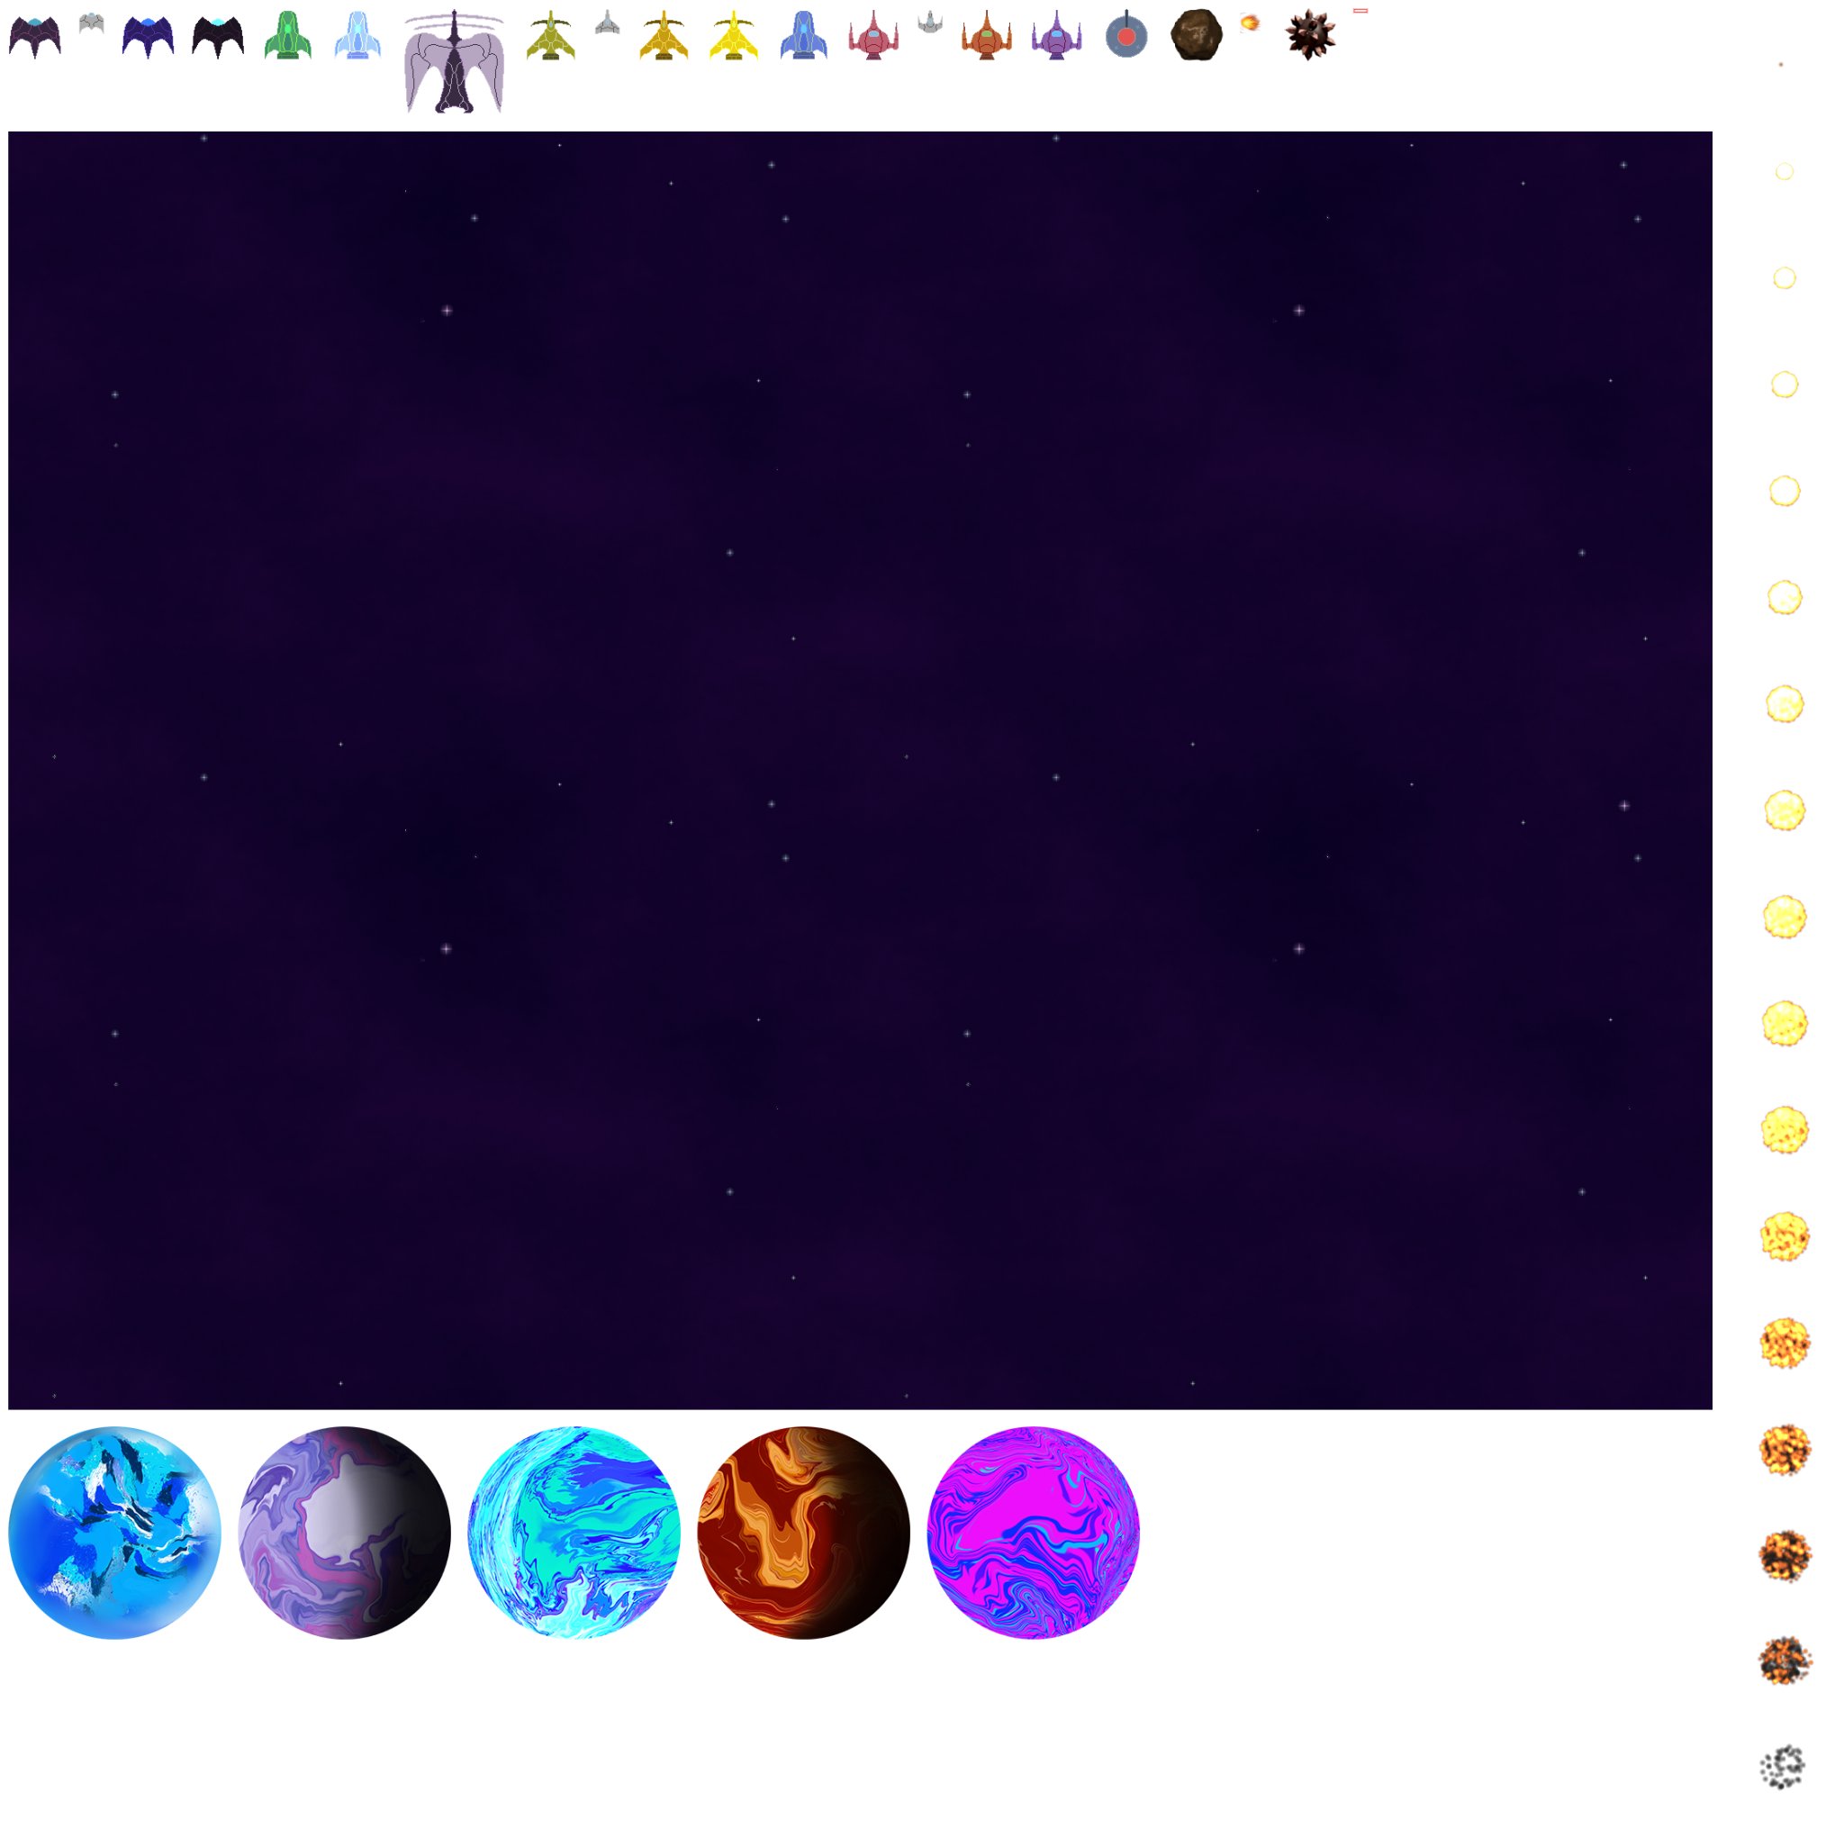

Communication

Communication is done over Discord asynchronously in a group chat. We discuss our responsibilities and progress there.

Project 2

| Project 2 | Tasks | Progress |
| --- | --- | --- |
| Finn Baldwin | Obstacles, power ups (placeholders until needed other needed code is finished, such as higher defense, quicker movement, and weapon upgrades) |  |
| Emily Flauto | Spritesheet implementation and base of project |  |
| Christian Angel | Enemy movement patterns |  |
| Kyira Fields | Ship movement, enemy bullet patterns, music |  |